**Name :Divya Bhambri**

**Roll No: 2021a1r179**

**Sem :5th**

**Subject : Python Programming**

**EXPERIMENT 2:**

**2.1 Write a program to illustrate iteration over the list.**

**list1=[10,10.5,'Apple',34,47]**

**length=len(list1)**

**while(1):**

**print('*****List Iteration*******')**

**print('1.Using For loop')**

**print('2.Using for with range')**

**print('3.Using while')**

**print('4.Using List Comprehension')**

**print('5.Using Enumeration')**

**print('6.Exit')**

**m=int(input('Enter your choice'))**

**if(m==1):**

**for i in list1:**

**print(i)**

**elif(m==2):**

**for i in range(length):**

**print(list1[i])**

**elif(m==3):**

**i=0**

**while i < length:**

**print(list1[i])**

**i += 1**

**elif(m==4):**

**[print(i) for i in list1]**

**elif(m==5):**

**for i, val in enumerate(list1):**

**print (i, ",",val)**

**else:**

**print('Exit from the program')**

**break**

**Output:**

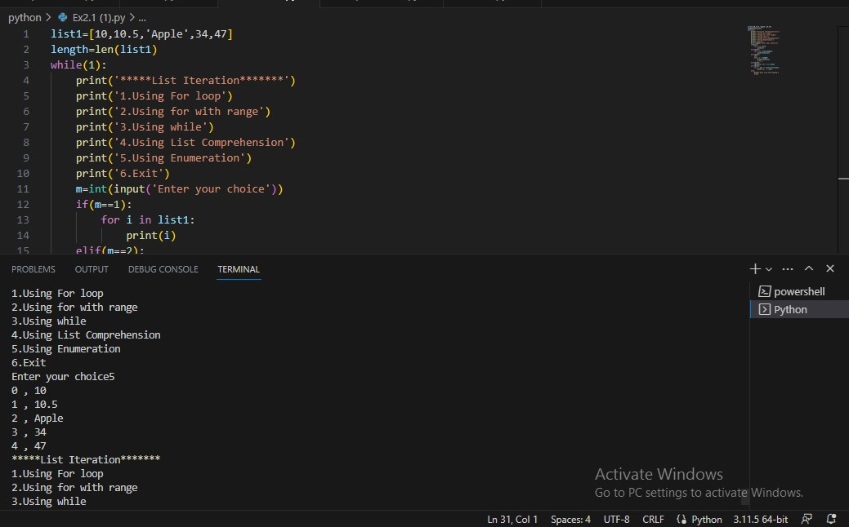

**2.2 Write a program to illustrate iteration over the dictionary.**

**d = {'key1': 1, 'key2': 2, 'key3': 3}**

**for k in d:**

**print(k)**

**print(list(d))**

**print(type(list(d)))**

**while(1):**

**print('********DICTIONARY ITERATION*********')**

**print('1.Through Dictionary keys()')**

**print('2.Through Dictionary values()')**

**print('3.Through Dictionary items()')**

**print('4.Exit')**

**c=int(input('Enter Your Choice'))**

**if(c==1):**

**for k in d.keys():**

**print(k)**

**print(d.keys())**

**print(type(d.keys()))**

**print(list(d.keys()))**

**print(type(list(d.keys())))**

**elif(c==2):**

**for v in d.values():**

**print(v)**

**print(d.values())**

**print(type(d.values()))**

**elif(c==3):**

**for k, v in d.items():**

**print('Keys=',k, 'Values=',v)**

**print(d.items())**

**print(type(d.items()))**

**elif(c==4):**

**break**

